Computer science

Project on

Hotel managenment

Project done by

1.revand.s

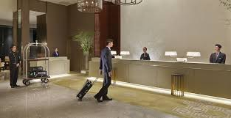

**SAINIK SCHOOL**

**KAZHAKOOTAM, TRIVANDRUM**



**Certificate**

**Certified Bonafide Record of Project Work done in Computer Science By revand s CBSE Reg No…………………………………AISSCE March 2019 during the academic year 2018-19. Examiner Master in Charge**

**Acknowledgement**

It is my duty to record sincere thanks and a sense of gratitude to my respected master,

**Mr Arunkumar G** for his valuable guidance and constant encouragement for the fulfillment of the project.

I am also higly obliged to assistant master

**Mrs Vindhya Areesh** and our lab assistant

**Mr Girikrishnan** who provided encouragement and support.

index

1. *Introduction*

2. *Basic Modules*

3. *Flow Chart*

4. *Survey of Technologies*

5. *Software and Hardware Requirements*

6. *External Modules Imported*

7. *Source Code*

8. *Data Base Details*

9. *Output Screen*

10. *Conclusion*

11. *Bibliography*

**introduction**

This project is based on the hotel management system.The program helps us to manage the hotel reservation system.The program helps the user to add the details of a hotel and even bill items

This program utilizes the advantages of classes,functions,data file handling etc.This program is purely based on the concepts of OBJECT-ORIENTED PROGRAMMING.

*Basic Modules*

Functions used in the project

1.Customerdata():this function is for entering the details of the customer like the customer_id,customer name,date of check in.

2.Roomcost():this function is for entering the details of the customer like the

customer _id,room cost,no of days of stay.this function is accessible using the function roomcost.

3.Foodbill():this function is for enter the details of the customer like the customer_id, the dishes had by the customer,the quantity of food items had by the customer.

4.delcust(): This function is for deleting the details of the customer from the tables room_data and food_details.Deletion from the table customer is not possible as it is the master table.Details of the customer can be viewed through the function showcust().

5.main():this is the main function in the the program.This function is used for calling all other functions of the program according to the

choice of the customer.

FLOW CHART

Add customer details

NO

GENERATE CSV FILE

DISPLAY THE ROOMBILL

DISPLAY THE FOODBILL

Add room details

Add food details

YES

**survey of technologies**

**Python** : python is an [interpreted](https://en.wikipedia.org/wiki/Interpreted_language), [high-level](https://en.wikipedia.org/wiki/High-level_programming_language), [general-purpose](https://en.wikipedia.org/wiki/General-purpose_programming_language) [programming language](https://en.wikipedia.org/wiki/Programming_language). Created by [Guido van Rossum](https://en.wikipedia.org/wiki/Guido_van_Rossum) and first released in 1991, Python's design philosophy emphasizes [code readability](https://en.wikipedia.org/wiki/Code_readability) with its notable use of [significant whitespace](https://en.wikipedia.org/wiki/Off-side_rule). Its language constructs and [object-oriented](https://en.wikipedia.org/wiki/Object-oriented_programming) approach aim to help programmers write clear, logical code for small and large-scale projects. Python is [dynamically typed](https://en.wikipedia.org/wiki/Dynamic_programming_language) and [garbage-collected](https://en.wikipedia.org/wiki/Garbage_collection_(computer_science)). It supports multiple [programming paradigms](https://en.wikipedia.org/wiki/Programming_paradigm), including [procedural](https://en.wikipedia.org/wiki/Procedural_programming), object-oriented and [functional programming](https://en.wikipedia.org/wiki/Functional_programming).

MYSQL:MySQL is open_source relational database management system.MySQL is free and open sourcesoftware under the terms of GNU-general public license.It is the world’s most popular open source database.With its proven performance, reliability,and ease-of – use,MySQLhas become the leading database choice for web-based application,used by high profile web properties including Facebook,Twitter,YouTube etc.

MysQL-Connector-Python: Python needs a MY SQL driver to access the my sql database.this is driver “MY SQL Connector” used to connect python and my sql databases.We can install this using PIPcommand.

pip install mysql_ connector-python

SOFTWARE & HARDWARE REQUIREMENTS

HARDWARE SPECIFICATIONS:

* PROCESSOR : PENTIUM DUAL CORE or ABOVE
* RAM : 2GB
* HARD DISk : 500GB
* MONITOR : 14” LED or ABOVE
* KEYBOARD : 104 KEYS
* MOUSE : OPTICAL MOUSE
* PRINTER : 24 PIN DOTMATRIX or ABOVE

SOFTWARE SPECIFICATIONS:

* OPERATING SYSTEM : WINDOWS 7 or ABOVE
* FRONT END : PYTHON 3 or ABOVE
* MIDDLEWARE : PYTHON-MYSQL CONNECTOR
* BACKEND : MYSQL

**External modules imported**

**import mysql.connector**

connect(),cursor(),fetchone(),fetchall(),execute(),commit()

* **from prettytable import pretty table**

PrettyTable(),add_row()

* **import time**

sleep()

* **from os import system**

system()

* import tkinter

Label()

source code

#project for hotel management

import mysql.connector as a

con=a.connect(host="localhost",user="root",

passwd="root",

database="hotel")

from prettytable import PrettyTable

from os import system

import tkinter

import time

def about():

print(" *****WELCOME TO HOTEL ELLIOT***** ")

print("This project is done by JOHN REVAND and ANKIT")

root=tkinter.Tk()

root.geometry("1940x480+25+25")

root.title('HOTEL ELLIOT')

w2=tkinter.Label(root,bg="red",fg="blue",text="WELCOME TO HOTEL ELLIOT",

font="CourierNew",relief="ridge",height=75, width=100)

w2.grid(row=0, column=0, sticky="ew")

w2.pack()

root.mainloop()

#------- This function is for entering customer data-------

def customerdata():

while True:

cuid=int(input("Customer ID:"))

fname=input("Enter first name:")

lname=input("Enter last name:")

rno=int(input("Room no:"))

contact=int(input("Contact no:"))

cont=str(contact)

if len(cont)<11:

print("ERROR IN ENTRY")

print("ENTER THE CORRECT NO OF DIGITS!!!!")

break

add=input("Address:")

cin=input("Check in date(YYYY-MM-DD):")

data=(cuid,fname,lname,rno,contact,add,cin,cout)

sql='insert into customer values(%s,%s,%s,%s,%s,%s,%s);'

c=con.cursor()

print("Successful entry")

time.sleep(3)

system('cls')

c=con.cursor()

c.execute(sql,data)

sql='select * from customer where cuid=%s;'

value=(cuid,)

c=con.cursor()

c.execute(sql,value)

data=c.fetchone()

system('cls')

t=PrettyTable(['cuid','fname','lname','roomno',

'contact','address','check_in'])

t.add_row(list(data))

print(t)

con.commit()

#------- This function is for calculating room rent-------

def roomcost():

ID=int(input("Customer ID:"))

fname=input("Enter first name:")

lname=input("Enter last name:")

rno=int(input("Room no:"))

cin=input("Enter check in date(YYYY-MM-DD):")

cout=input("Enter check out date(YYYY-MM-DD):")

stay=int(input("Enter duration of stay:"))

suite={"Presidential":2000,"VIP":1500,"Luxury":1300,"Economical":950}

print('''Enter room types(Presidential,VIP,Luxury,Economical''')

rtype=input("Enter suite:")

dmg=input("Damages occured(y/n):")

cost=stay*suite[rtype]

if dmg=="y" or dmg=="Y":

fcost=cost+2000

print(fcost)

else:

fcost=cost

print(fcost)

data=(ID,fname,lname,rno,cin,cout,stay,rtype,dmg,fcost)

sql='insert into room_data values(%s,%s,%s,%s,%s,%s,%s,%s,%s,%s)'

c=con.cursor()

print("Successful entry")

time.sleep(1)

system('cls')

c=con.cursor()

c.execute(sql,data)

con.commit()

#-------this function is for entering food details during stay

#of customer---------

def fooddata():

cuid=input("Customer ID:")

name=input("Enter name:")

print("If Breakfast enter 1")

print("If lunch enter 2")

print("If dinner enter 3")

print("If snacks enter 4")

dish_no=int(input('Enter food code:'))

number=int(input('Enter quantity:'))

sql='select cost,food from menu where dish_no =%s ;'

value=(dish_no,)

c=con.cursor()

c.execute(sql,value)

data,=c.fetchall()

print(data)

cost=data[0]

food=data[1]

total=cost*number

print('The total cost is:',total)

data=(cuid,name,dish_no,number,total)

sql='insert into food_details values(%s,%s,%s,%s,%s);'

c=con.cursor()

c.execute(sql,data)

con.commit()

#------- this function is for deleting customer data--------

def delcust():

cuid=int(input("Customer ID:"))

ch=input("Do you want to delete customer details(y/n):")

if ch=="y" or ch=="Y":

sql='delete from room_data where Cuid=%s;'

value=(cuid,)

c=con.cursor()

c.execute(sql,value)

con.commit()

sql='delete from food_details where Cuid=%s;'

value=(cuid,)

c=con.cursor()

c.execute(sql,value)

con.commit()

#-------this function is for showing food bill--------

def show_foodbill():

ch=input("Do you want details of one customer or entire customers(y/n):")

cuid=input("Customer ID:")

sql='select * from food_details where cuid=%s;'

value=(cuid,)

c=con.cursor()

c.execute(sql,value)

data=c.fetchone()

system('cls')

t=PrettyTable(['Cuid','Name','Food_code','Quantity','Cost'])

t.add_row(list(data))

print(t)

#--------this function is for showing roombill--------

def show_roombill():

ch=input("Do you want details of one customer or entire customers(y/n):")

if ch=='n' or ch=='N':

sql='select Cuid,First_name,Room_no,Check_in,Check_out,Suite,Cost from room_data;'

c=con.cursor()

c.execute(sql)

data=c.fetchall()

system('cls')

t=PrettyTable(['Cuid','First_name','Room_no','Check_in',

'Check_out','Suite','Cost'])

for i in data:

t.add_row(list(i))

print(t)

else:

cuid=int(input("Customer ID:"))

sql='select * from room_data where cuid=%s;'

value=(cuid,)

c=con.cursor()

c.execute(sql,value)

data=c.fetchone()

system('cls')

t=PrettyTable(['cuid','First_name','Last_name','Room_no',

'Check_in','Check_out','Duration','Suite',

'Damages','Cost'])

t.add_row(list(data))

print(t)

#--------this function is for showing customer details--------

def showcust():

ch=input("Do you want details of one customer or entire customers(y/n):")

if ch=='n' or ch=='N':

sql='select cuid,fname,roomno,contact,address from customer;'

c=con.cursor()

c.execute(sql)

data=c.fetchall()

system('cls')

t=PrettyTable(['cuid','fname','roomno','contact',

'address'])

for i in data:

t.add_row(list(i))

print(t)

else:

cuid=int(input("Customer ID:"))

sql='select * from customer where cuid=%s;'

value=(cuid,)

c=con.cursor()

c.execute(sql,value)

data=c.fetchone()

system('cls')

t=PrettyTable(['cuid','fname','lname','roomno','contact',

'address','check_in','check_out'])

t.add_row(list(data))

print(t)

#----Main Function-------

def main():

while (1):

system('cls')

print("\t\t--------------------------------")

print("\t\t HOTEL ELLIOT ")

print("\t\t--------------------------------")

print("\t 1.ABOUT US")

print("\t 2.ENTER CUSTOMER DETAILS")

print("\t 3.CALCULATE ROOMRENT")

print("\t 4.CALCULATE FOODBILL")

print("\t 5.DISPLAY CUSTOMER DETAILS")

print("\t 6.DISPLAY ROOM DETAILS OF CUSTOMER")

print("\t 7.DISPLAY FOOD DETAILS OF CUSTOMER")

print("\t 8.DELETE CUSTOMER DETAILS")

print("\t 9.EXIT")

ch=int(input("ENTER YOUR CHOICE:"))

if ch==1:

about()

elif ch==2:

customerdata()

elif ch==3:

roomcost()

elif ch==4:

fooddata()

elif ch==5:

showcust()

elif ch==6:

show_roombill()

elif ch==7:

show_foodbill()

elif ch==8:

delcust()

elif ch==9:

break

else:

print("Enter correct choice!!")

#---main function call---

main()

Data base details

Table customer

create table customer(cuid int(11) primary key not null unique,fname varchar(20) not null,

lname varchar(20),roomno int(4) not null,contact varchar(20),address varchar(50),

check_in date);

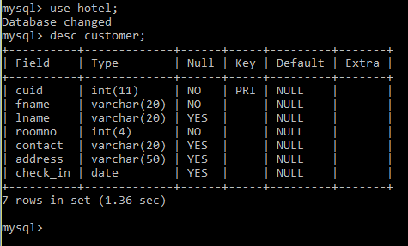

Table room_data

create table room_data(Cuid int(11) not null primary key unique,First_name varchar(15) not null,Room_no int(11),Check_in date,Check_out date,

Duration int(11) not null,Suite varchar(15) not null,Damages char(1),

Cost int(11),Foreign Key(Cuid) references customer(cuid));

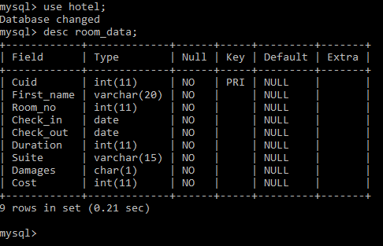

Table food_details

create table food_details(Cuid int not null primary key unique,Name varchar(15) not null,

Food_code int not null,Quantity int not null,Cost int not null,

Foreign Key(Cuid) references customer(cuid));

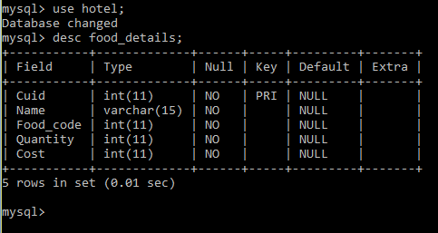

Table menu

create table menu(dish_no int(5) not null,food varchar(15),cost int(5));

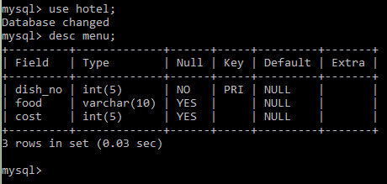

screen shots

Showing project details

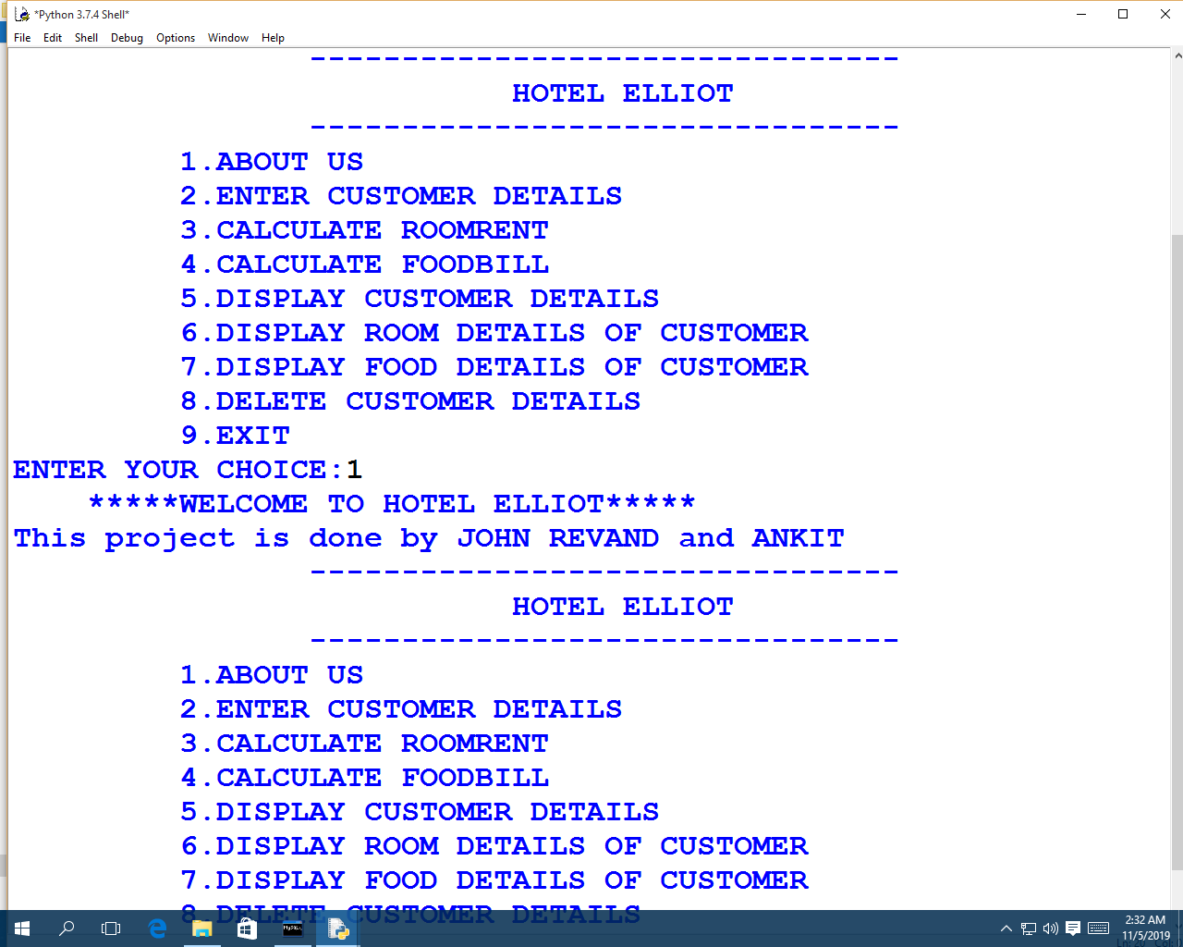

Entering customer details

Entering room details of customer

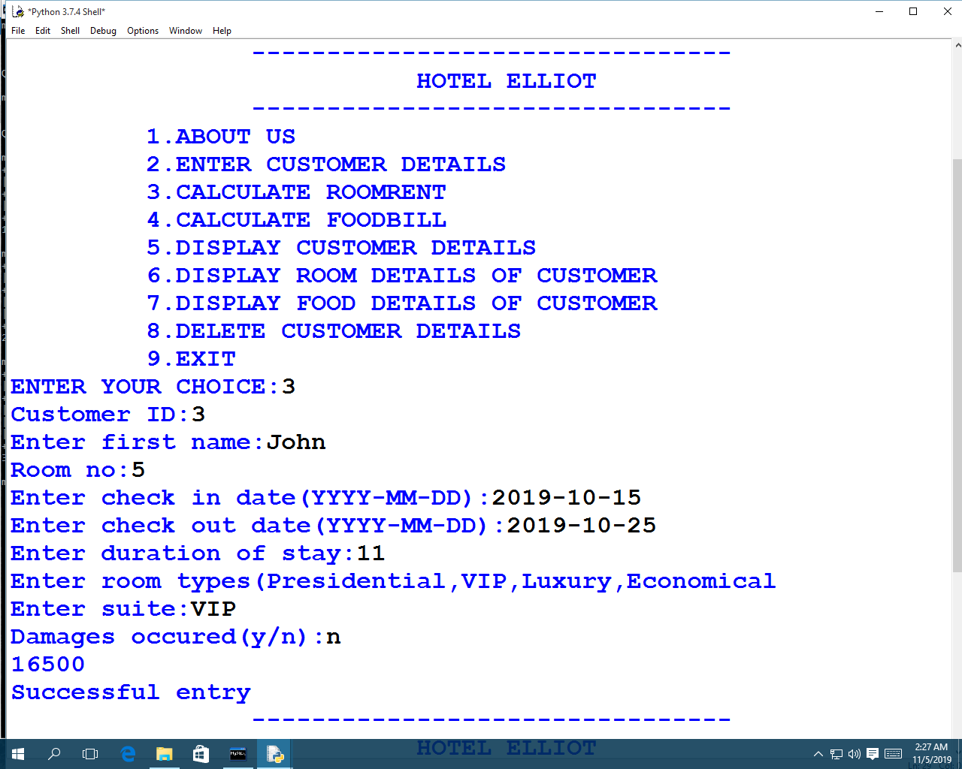

Entering food details of customer

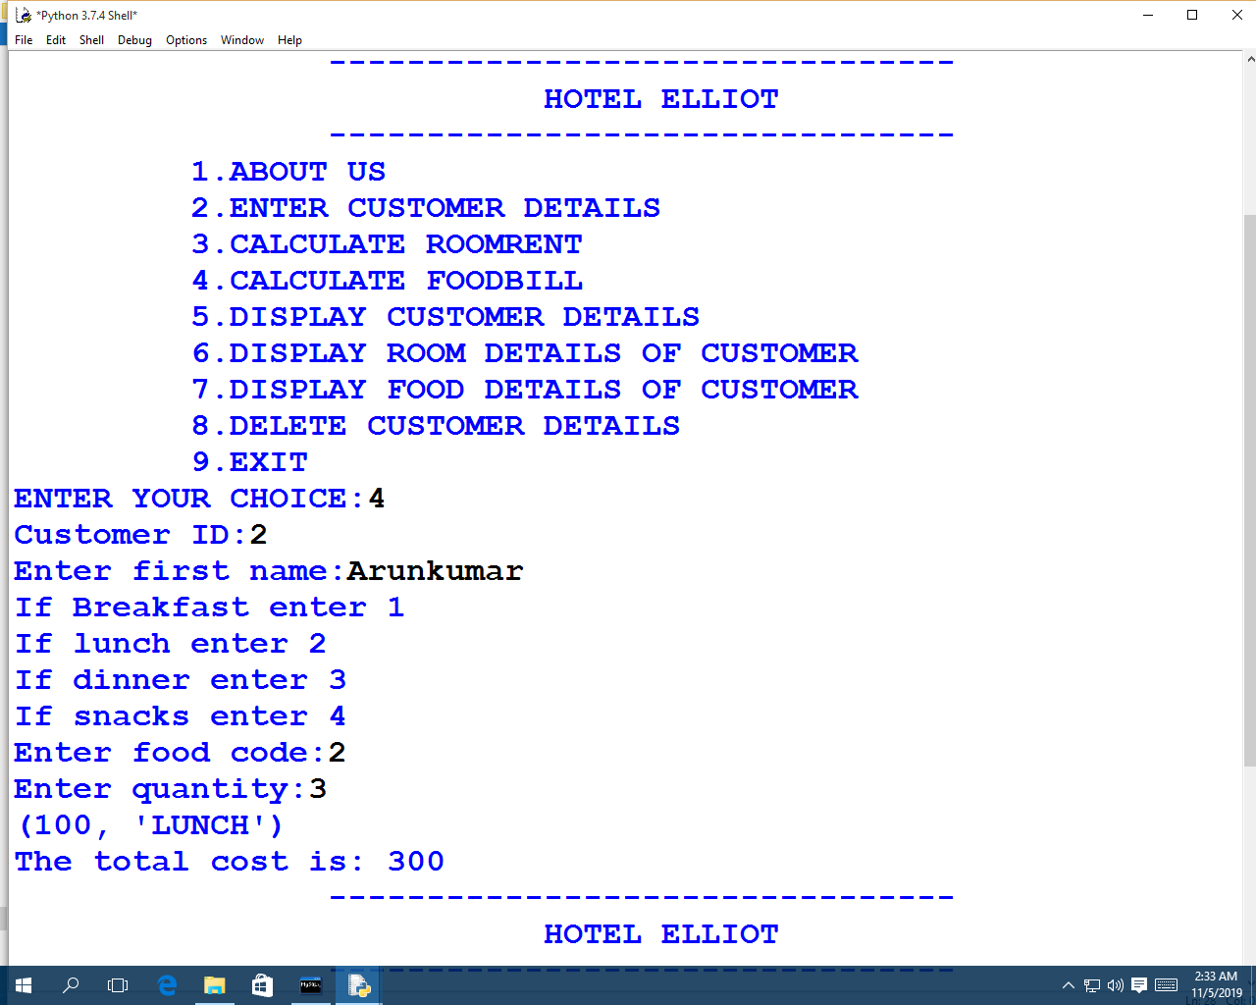

Displaying a particular customer’s details

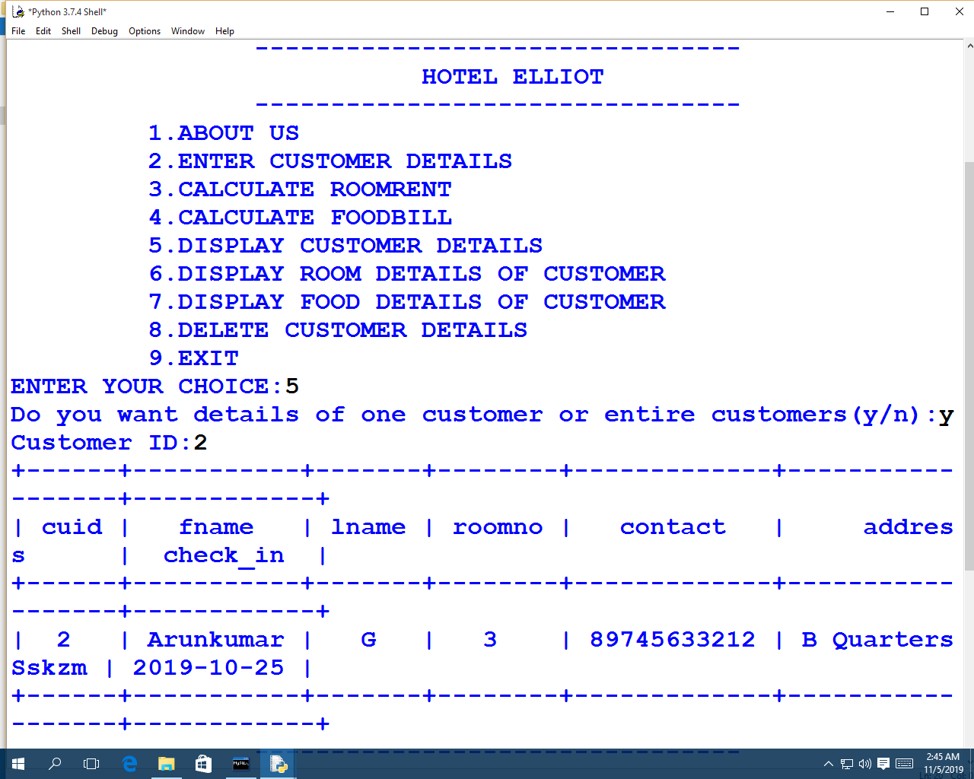

Displaying details of full customers

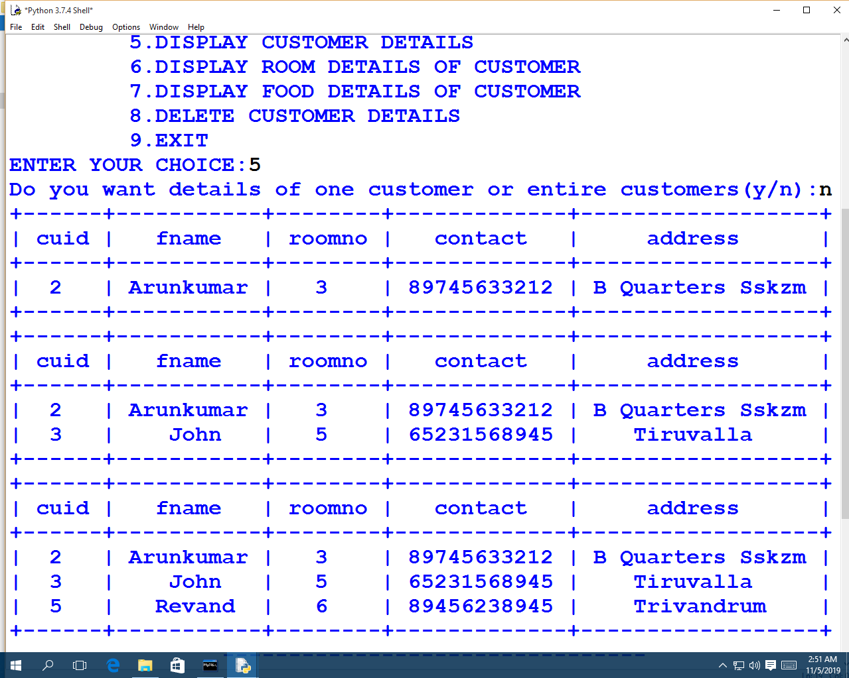

Displaying food details of a particular customer

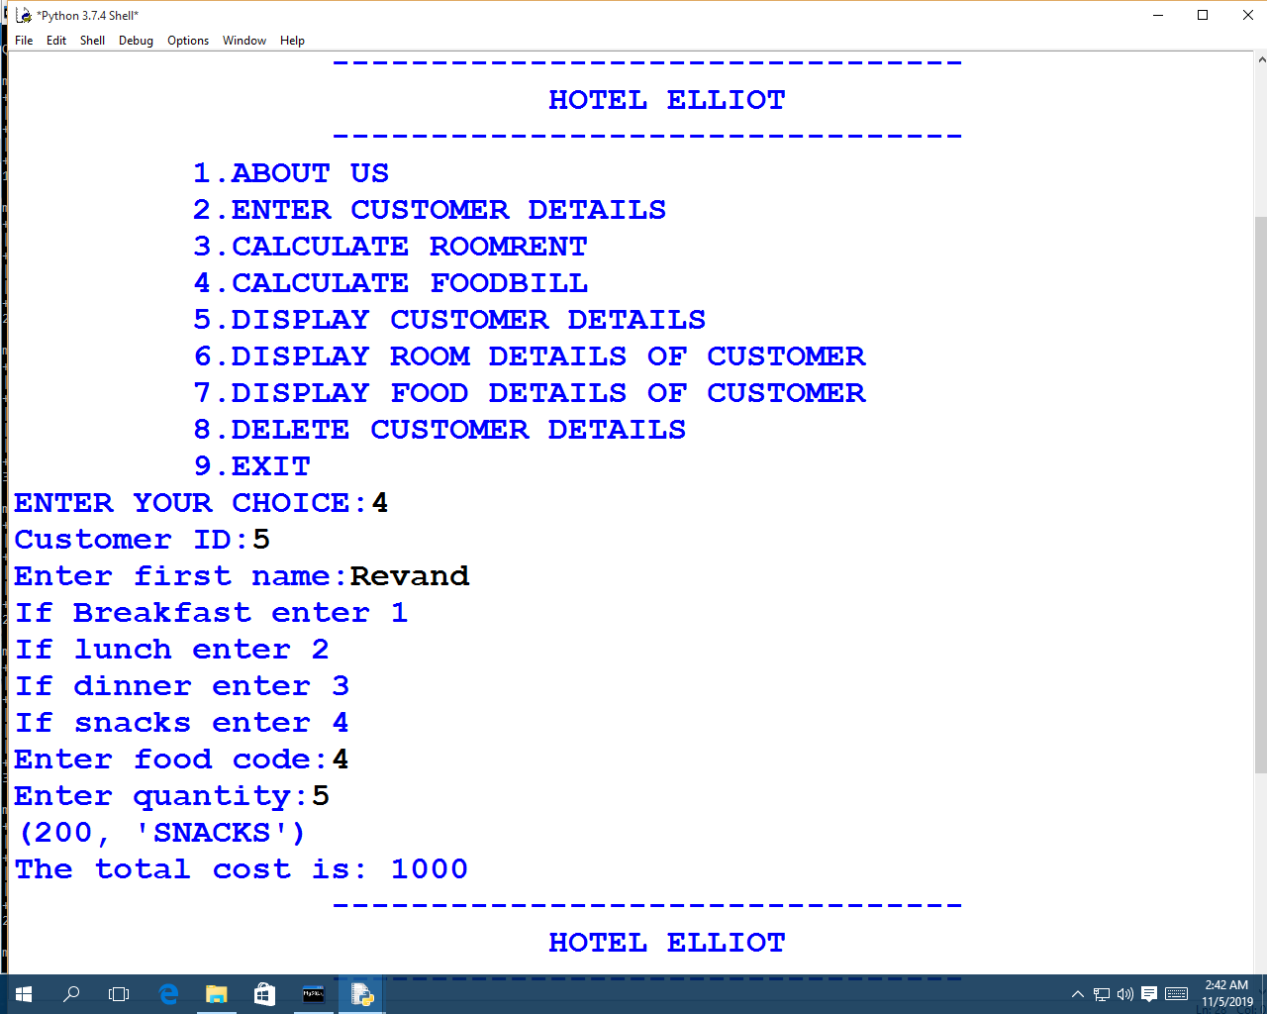

Displaying food details of all customers

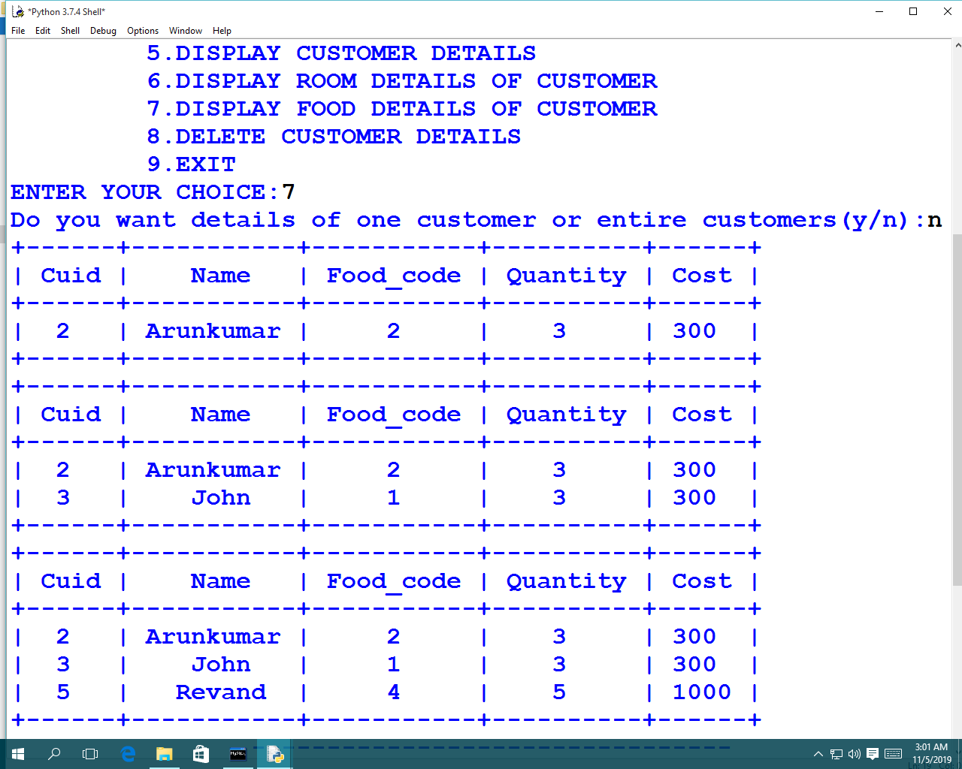

Displaying room details of a particular customer

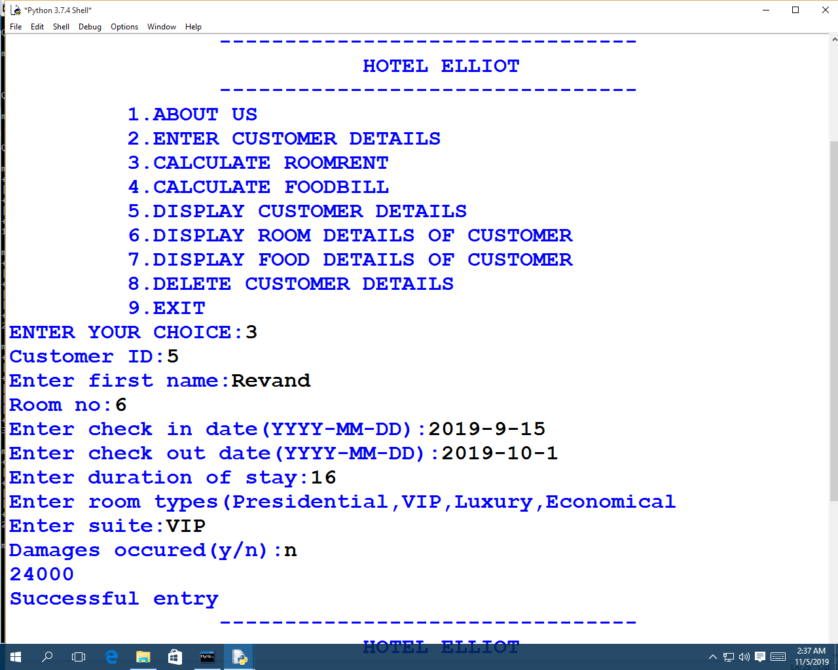

Displaying room details of all customers

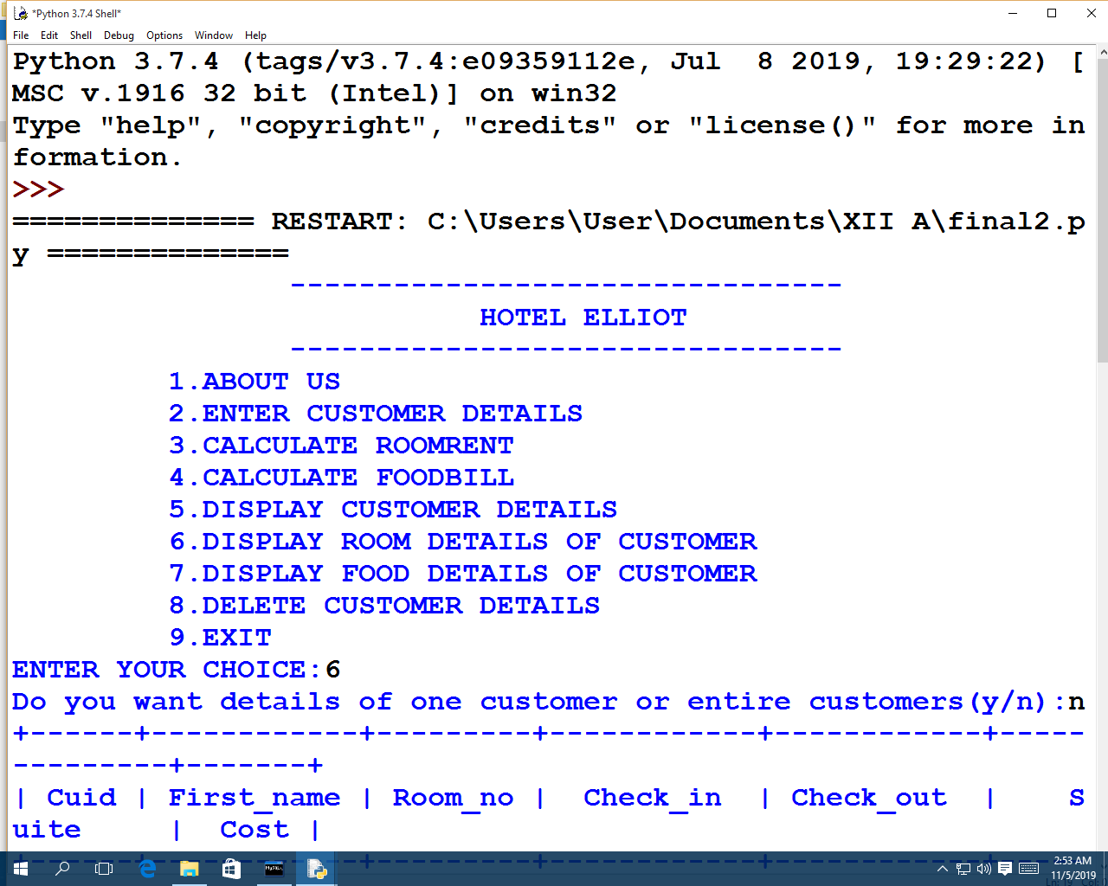

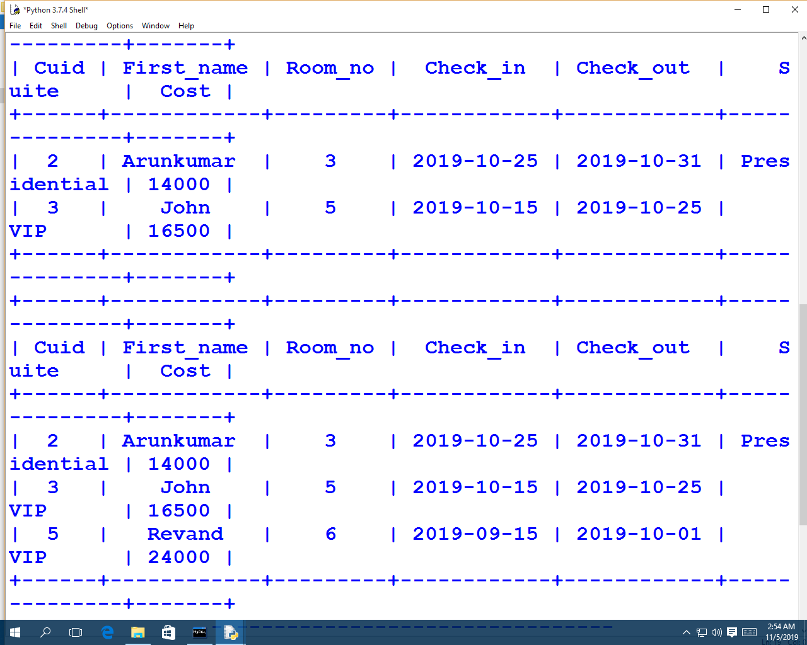

Deleting customer details

MySQL now contains details of the remaining customers

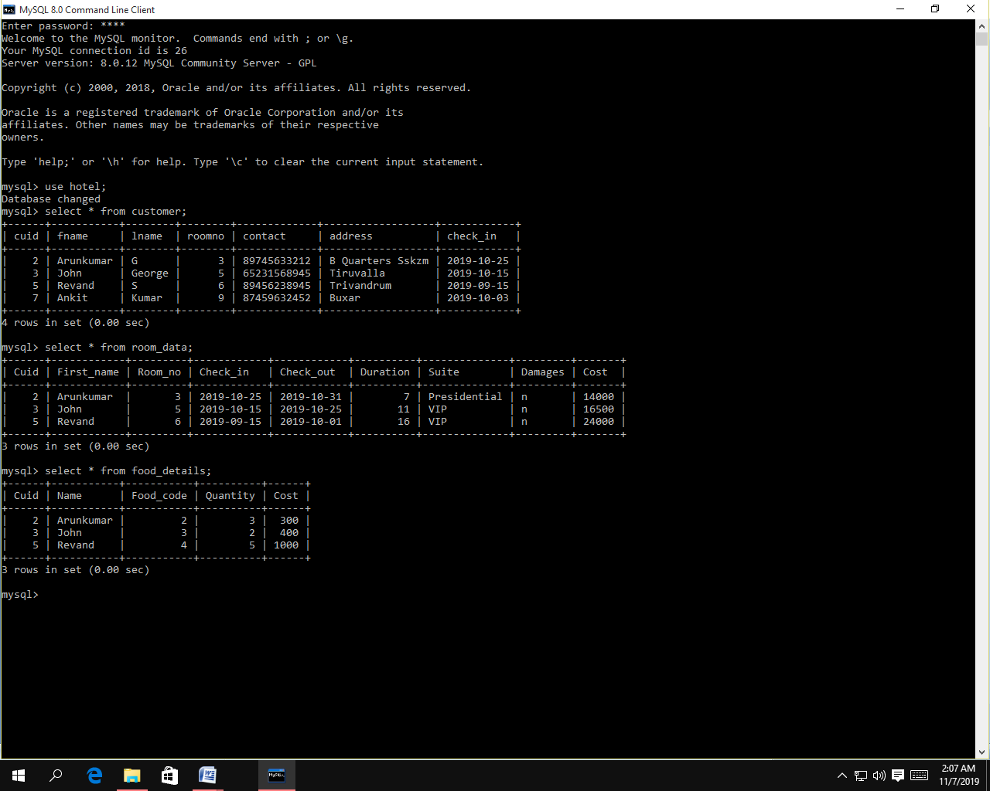

**CONCLUSION**

**This Project “*HOTEL MANAGEMENT SYSTEM*” will help us to book our hotel rooms and it also generates bill.**

**The whole system is menu driven and hence user-friendly.This system was develo*ped to make the management of a* *hotel* much easier**

**and user friendly.**

**This system is checked and proved to be error free and is highly portable.The system is suitable for modern hotel reception requirements and is highly effective.**

**BIBLOGRAPHY**

* **COMPUTER SCIENCE TEXTBOOK CLASS XII**
* [**WWW.ICBSE.COM**](http://WWW.ICBSE.COM)
* [**WWW.CPPFORSCHOOL.COM**](http://WWW.CPPFORSCHOOL.COM)
* [**WWW.WIKIPEDIA.COM**](http://WWW.WIKIPEDIA.COM)

**REMARKS**

**www.stackoverflow.com**